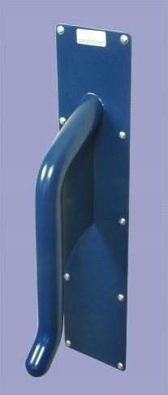ant22modepc
Dortrend International ltd product information sheet
Product ref.no. ant22modepc vertical grab rail for use in assisted washrooms where there is a possibility of self-harm
Material: manufactured from aisi 304 stainless steel tube and sheet to prevent corrosion
Finish: polyester powder coated and finished with TouchClean®anti-microbial coating for more information on this coating visit www.dortrend.co.uk/product/1007
Fitting: the product is supplied with anti-tamper screws this product is designed to resist ligature attachment and therefore must be fitted vertically for horizontal rails use ANTGRPC rails. When fitting this product do not fit to partitioning that is not fully flush with the ceiling and accessible from behind as part of the risk assessment consider proximity to other potential secondary ligature points. For example do not fit to doors.
Care and Maintenance: Monthly check fixings are firmly in place and check the product for damage.Cleaning do not use bleach or abrasive cleaners as it will damage the surface wash with warm soapy water as necessary
For product Support contact us on 01299 827837 [uk] 00441299827837[outside uk]

