DORTREND INTERNATIONAL LTD PRODUCT INFORMATION SHEET DT97/IN

_____________________________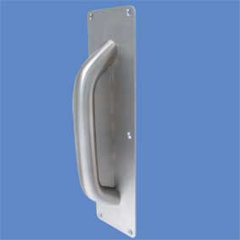_
PRODUCT REF,NO ANT25INFILSSS

PRODUCT DECRIPTION Ligature resistant pull handle for face fixing to wooden doors 25mm dia pull fitted to infil and back plate.

MATERIAL AISI 304 STAINLESS STEEL SATIN POLISHED

FITTING INSTRUCTIONS position the handle and mark out the position counterbore two holes to ensure that the bolts do not prevent the plates from sitting flat on the door do not use power drivers to fix the torx pin screws provided as this will damage the screws and prevent either the screws being screwed fully home or prevent authorised removal.
CARE AND MAINENANCE quarterly check screws are tight and that there is no damage to the handle in the very unlikely event of the handle being loose on the plate remove the handle from the door and tighten the bolt if the handle becomes loose again apply threadlock to the bolts. The surface of this product does not require specific maintenance clean with a damp cloth or non abrasive polish.

Need more information call our sales office on 01299 827837 or from outside the UK 441299827837

