DORTREND INTERNATIONAL LTD PRODUCT INFORMATION SHEET

PRODUCT REF NO. ANT19 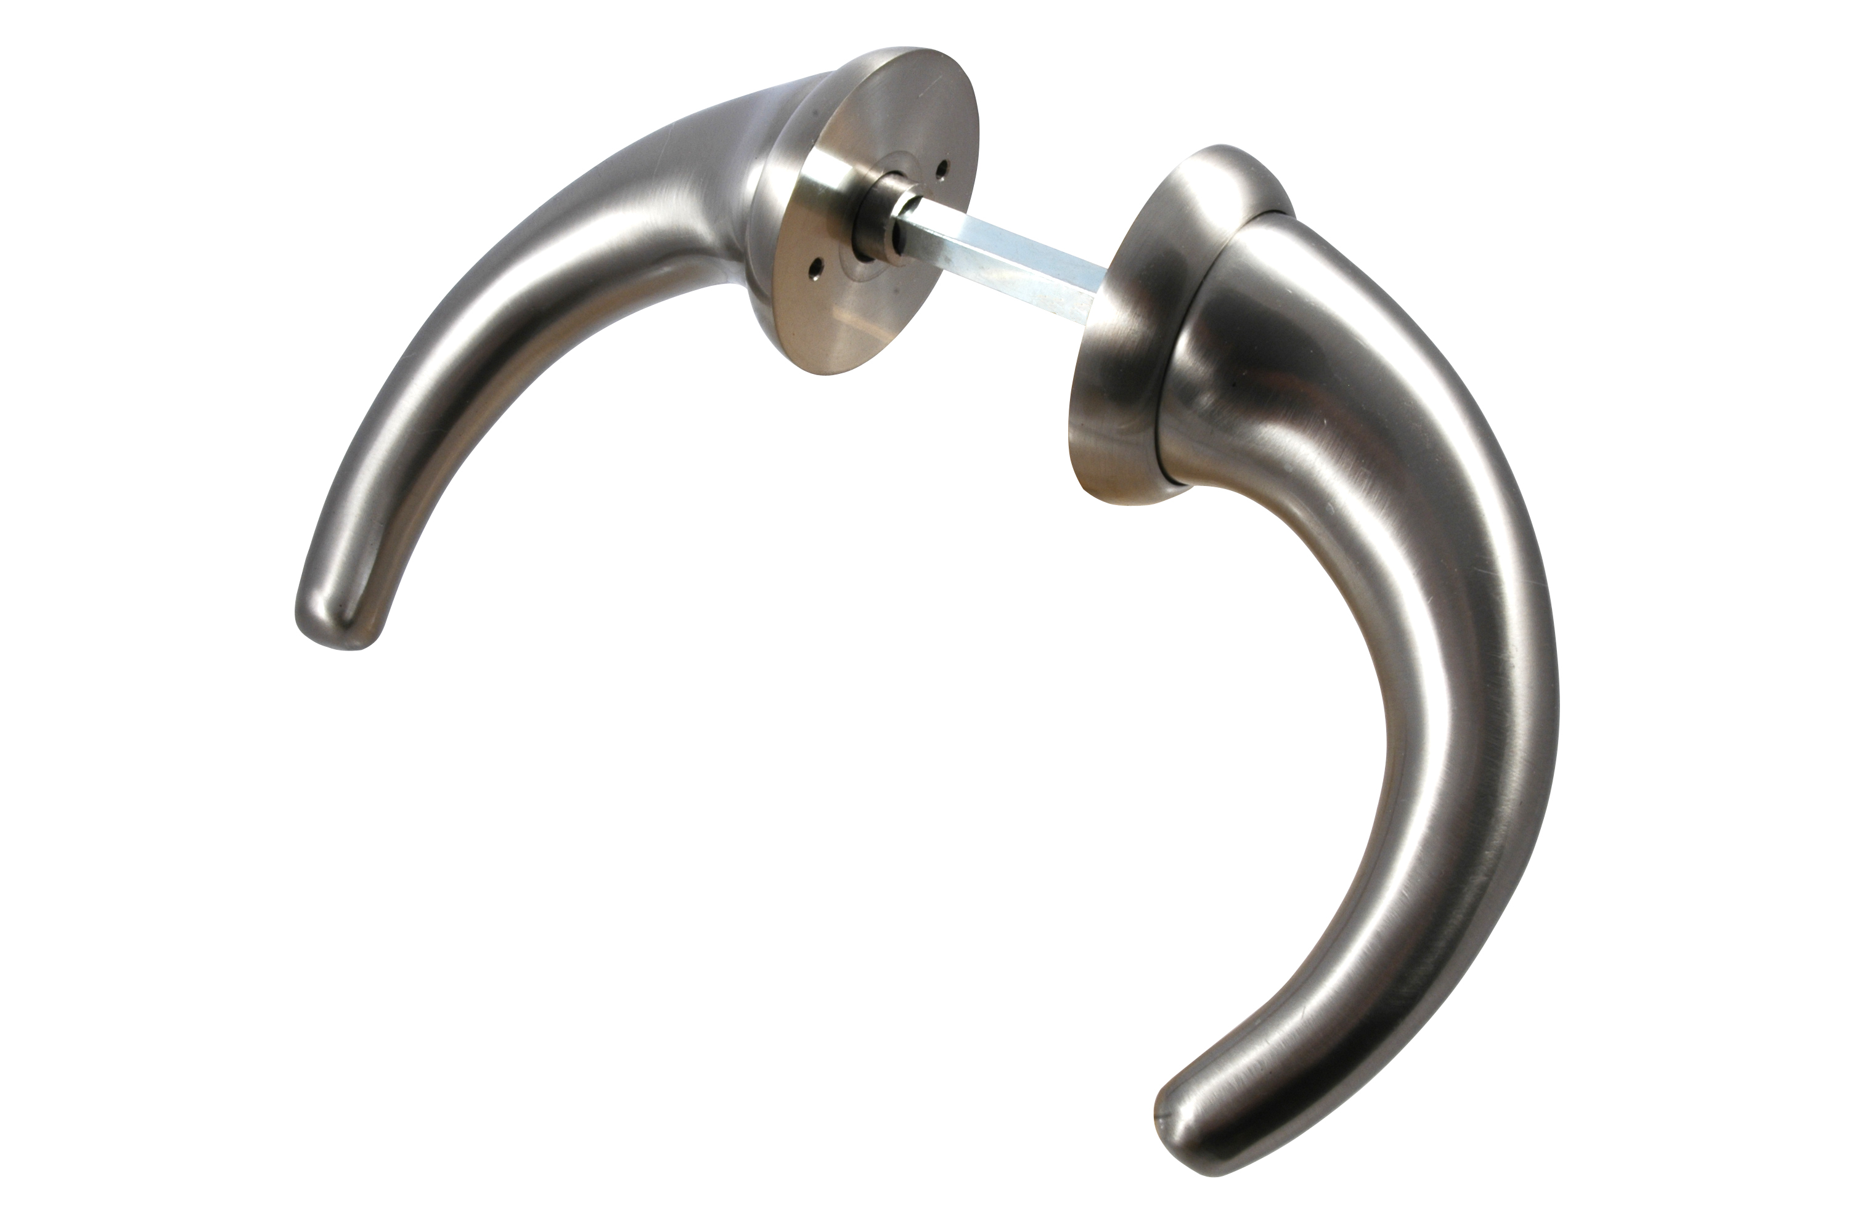
FULL PRODUCT DESCRIPTION ligature resistant lever handle

Material aisi 304 stainless steel or aluminium

DESIGN SPECIFICATION designed for use in facilities where users of the building might self harm by attaching ligatures to handles.
PARTS LIST pair of handles, Heso type spindle two roses, one pointed grub screw two grub screws. bolt through fittings two alun key
FITTING INSTRUCTIONS the lever is designed to sit on the door at 45 degree angle. Drill a hole through the door appropriate to the position of the lock follower 16mm in dia then drill two holes 6mm dia 38mm centres[19mm to centre line of 16mm hole.]Ensure that fixings are not visible on the client side of the door.
Present the lever with the fixed rose to the door using the bolts provided bolt the rose to the levers present the lever to the spindle ensuring that the thin wall of the spindle faces the grub screw hole tighten the pointed grub screw ensuring it pierces the spindle then back up the grub screw with the grub screw provided.
TROUBLE SHOOTING lever does not return fully is lock spring strong enough to return lever? Return of the lever will be compromised if the lock is not straight in the door or levers are not sitting parallel to each other Handles are working loose check that the pointed grub screw has pierced the thinner wall of the spindle. it will click as it pierces the spindle wall ensures back up grub screw has been used.
CARE AND MAINTAINCE clean with a damp cloth for more stubborn marks use soapy water do not use abrasive polishes check tightness of grub screws regularly.
TOUCHCLEAN ANTIBACTERIAL COATING all our products can be coated with an anti bacterial coating which kills 99.9% of mrsa and other harmful bacteria.

