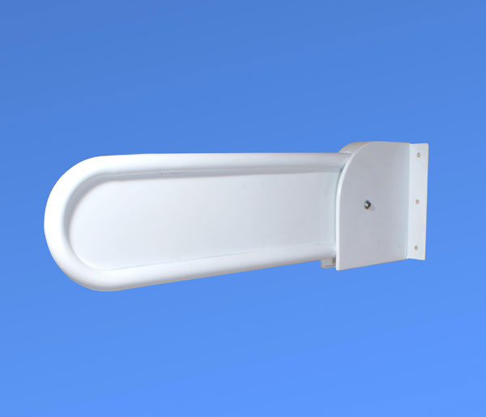

Product Information sheet ANTPCWTCST
Description ligature resistant locking washroom support arm designed for use in washroom areas where service users may attempt to self-harm
Materials used AISI 304 stainless steel tube and sheet welded to provide a very strong construction which is resistant too corrosion[inferior mild steel will corrode in time as powder coating is semi porous] powder coated with soft touch epoxy coating Coated with our TouchClean®anti-microbial coating. Laboratory test certification available on request.
Design and function the arm is designed to offer support whilst using the facilities and to offer service users support whilst sitting down or rising from a sitting position. It is designed for use by clients up to 25 stone putting their full weight on the rail. It should be noted that the rail must be securely fixed to the wall using suitable fixings and consideration should be given to the material make-up of the wall e.g. if it is a composite partition the rail should be bolted on for extra strength and security. The rail has been designed to be locked down vertically when not in use and locked horizontally for supervised use of the washroom. Two keys are provided which can be keyed alike if a number of rails are in use.
Care and maintenance the surface should be washed periodically using warm soapy water to remove stains bleach should not be used as the surface is self-cleaning fixings to the wall should be checked for tightness four weekly and the action of the rail likewise should be checked for free movement or damage. Rails must be locked down when not in use with periodic checking of the locks and keys for function.

