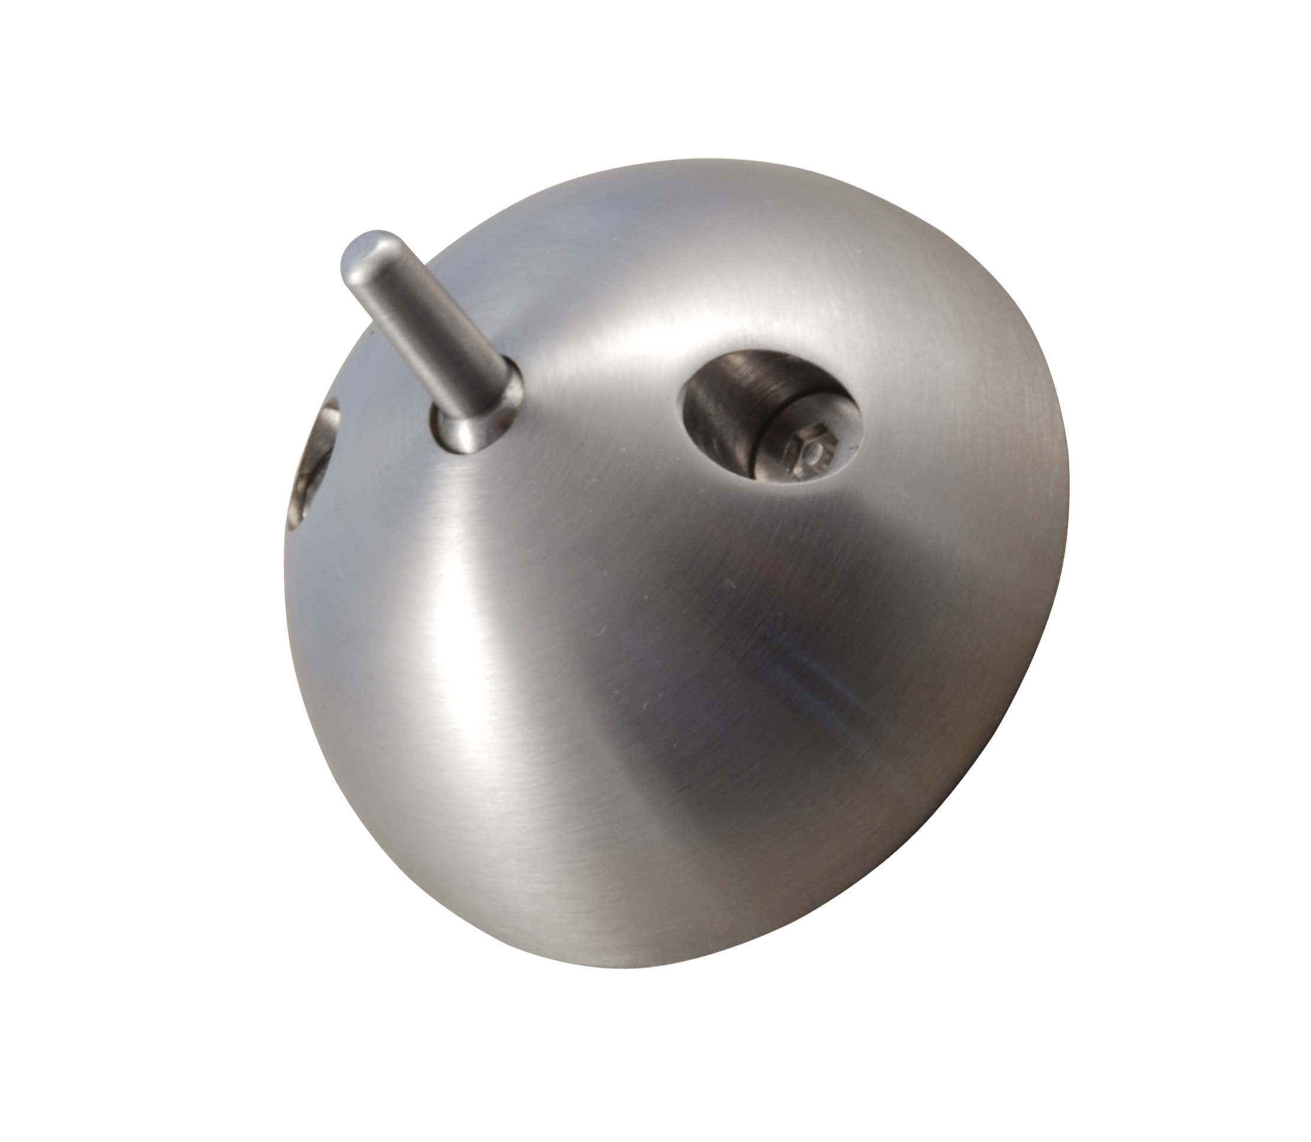Anti-ligature Series
Antch1sss
Antch1as

FULL PRODUCT DESCRIPTION: ligature resistant coat hook adjustable

MATERIAL: satin stainless steel
Anodised aluminium

DESIGN SPECIFICATION: Designed for use in facilities where conventional coat hooks might be used as ligature points. Supplied set to support 2 kilo [enough for most garments].Weight bearing can be increased by tightening the adjuster screw in the base with a 6mm alan key do not over tighten as this will jam the pin in place. Supplied with two 8mmx2mm screws Do not use power drivers as this will damage the torx pin heads and will prevent the screws being screwed tightly enough to ensure the base is flat to the host surface.

PARTS LIST: 1 coat hook two 8x2 torx pin screws

FITTING INSTRUCTIONS: Adjust as required follow procedures above when positioning the product consider placing as high as practicable. if fitting to a door avoid offering a secondary ligature support by mounting well away from the edges of the door.

TROUBLE SHOOTING: pin does not drop under required weight remove and adjust the screw in the base. Base does not sit flat on the host surface check screws are fully tightened and that adjuster screw is not projecting beyond the base.If host surface is not flat and gaps show around the base counterbore a 63mm dia hole 3mm deep.

CARE AND MAINTAINENCE: monthly : check pin falls easily if not remove and adjust if damaged replace. Check fixings to host surface are tight
Annually remove and unscrew adjuster screw and grease ball/ spring mechanism.
Cleaning with a damp cloth is all that is necessary if soiled soap and warm water can be used.
Do not use abrasive polishes as it will damage the polished surface.

TOUCHCLEAN ANTIBACTERIAL COATING: All Dortrend products can be supplied with our anti bacterial coating which kills 99.9% of MRSA and other bacteria.

Dortrend International ltd retains the right to change design features of its products without notice if the product featured varies from the above please contact us for an updated product information sheet. Thank you for purchasing our product

