DORTREND INTERNATIONAL LTD

PRODUCT INFORMATION SHEET 91/5--SSS ANT5

-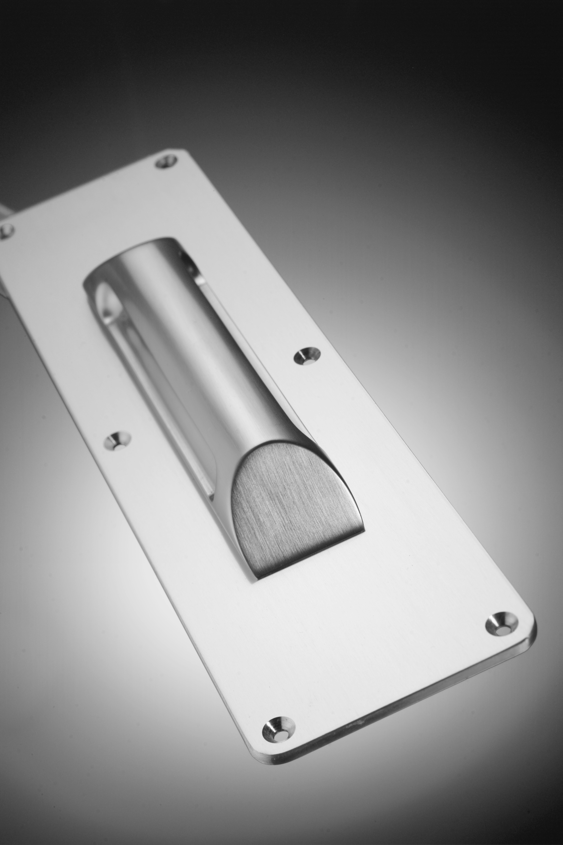
PRODUCT REFERENCE NUMBER ANT5SSS
PRODUCT DESCRIPTION PULL HANDLE DESIGNED TO RESIST THE ATTACHMENT OF LIGATURES SUPPLIED AS ILLUSTRATED ON PLATE FOR FACE FIXING USING TORX PIN SCREWS PROVIDED OR BACK FIXED USING BOLTS SUPPLIED.DESIGNED FOR USE ON CUPBOARDS INSPECTION HATCHES LIGHT DOORS.DO NOT USE WITH DOOR CLOSING DEVICES AS THERE IS INSUFFICIENT GRIP FOR EASY OPENING OF DOORS AGAINST RESISTANCE OF DOOR CLOSERS ETC.
MATERIAL: investment cast stainless steel non magnetic therefore rust resistant linished and satin polished
FITTING INSTRUCTIONS pull handle on plate: rout area of where handle is to be located to a depth of 2mm so that plate sits neatly in the routed area sufficient material to sink the bolts holding the handle onto the plate to allow it to sit flush. do not use power screw drivers as they damage torx pin screws and prevent them from being screwed firmly into the surface.ANT5 BOLT THROUGH: prepare the door by routing area that the pull handle is to be located so that the base of the handle sits 2mm below the surface drill two holes 10mm dia 100mmc/c apart present the handle to door and firmly fit the two m8 screws provided ensure that the screws are countersunk into the door surface and covered with the appropriate plate [not supplied]
CARE AND MAINTAINANCE the surface is maintenance free, wipe with damp cloth or non abrasive polish as required, quarterly: check and tighten fixings as appropriate.
NEED MORE INFORMATION CONTACT OUR SALES OFFICE ON 01299 827837 OUTSIDE UK 00441299827837

