During 2014 while Geoff Woodyatt was working as a building surveyor for the NHS 2gether Foundation Trust, an incident occurred where a nurse’s fingers were severed in the meeting edges of double ward doors. After extensive searches of available products Geoff could not find a solution to this problem. He therefore decided to design a new handle that removed the risk of finger trapping and installed them on the doors where the incident took place. The handle worked so well that he now has the IP rights for the UK and EU and has designed a door frame to further reduce the possibility of pinch points. Quattro Design Ltd have specified the handles and door frames for a recent refurbishment project in another of the Trust’s properties. Dortrend International Ltd are licensed to manufacture and market Geoff’s design.

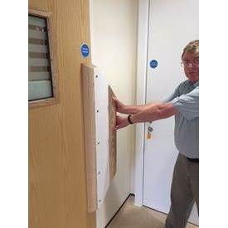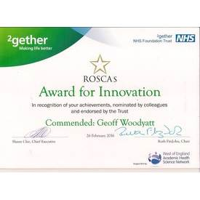

For further details contact Dortrend International Ltd Email: sales@dortrend.co.uk
Phone 01299 827837 for details of our extensive range of Anti-ligature door and window fittings visit www.dortrend.co.uk., Dortrend International Ltd, Riverside Business Centre, Worcester Road, Stourport on Severn, Worcestershire, DY13 9BZ

