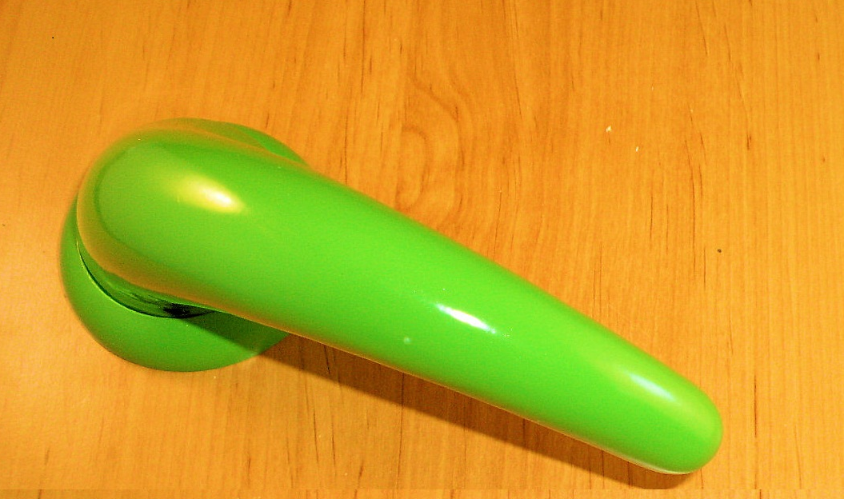

This photo shows the Ant19 lever handle powder coated to a specific Ral number, we can supply this product in any requested Ral number to match in with the scheme, as we supplied on this project. We also supplied ancillary products such as the Antatifm12 in this finish.
After supplying the green finish we were contacted to supply Anti-ligature grab rail and shower rail in a blue ral 5011 for any information on our new range of grab rails and shower rails please contact the sales office on sales@dortrend.co.uk

