DORTREND INTERNATIONAL LTD- PRODUCT INFORMATION SHEET

PRODUCT REF. NO ANTAT1FMI2CLSSS

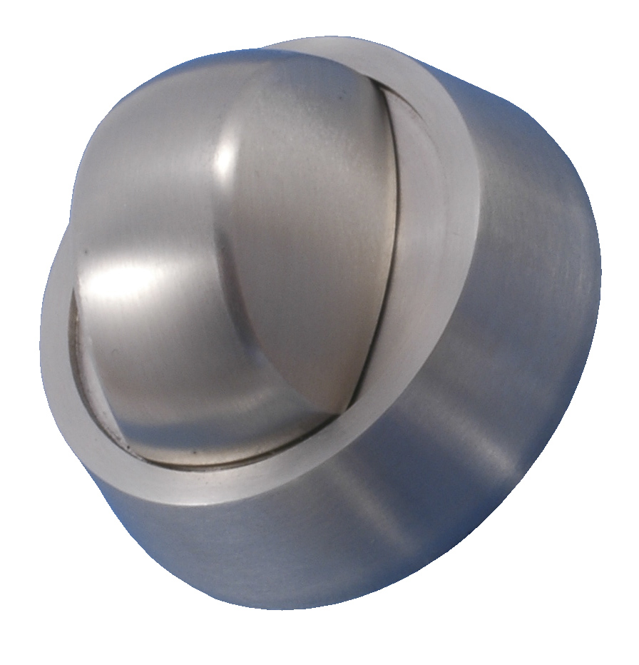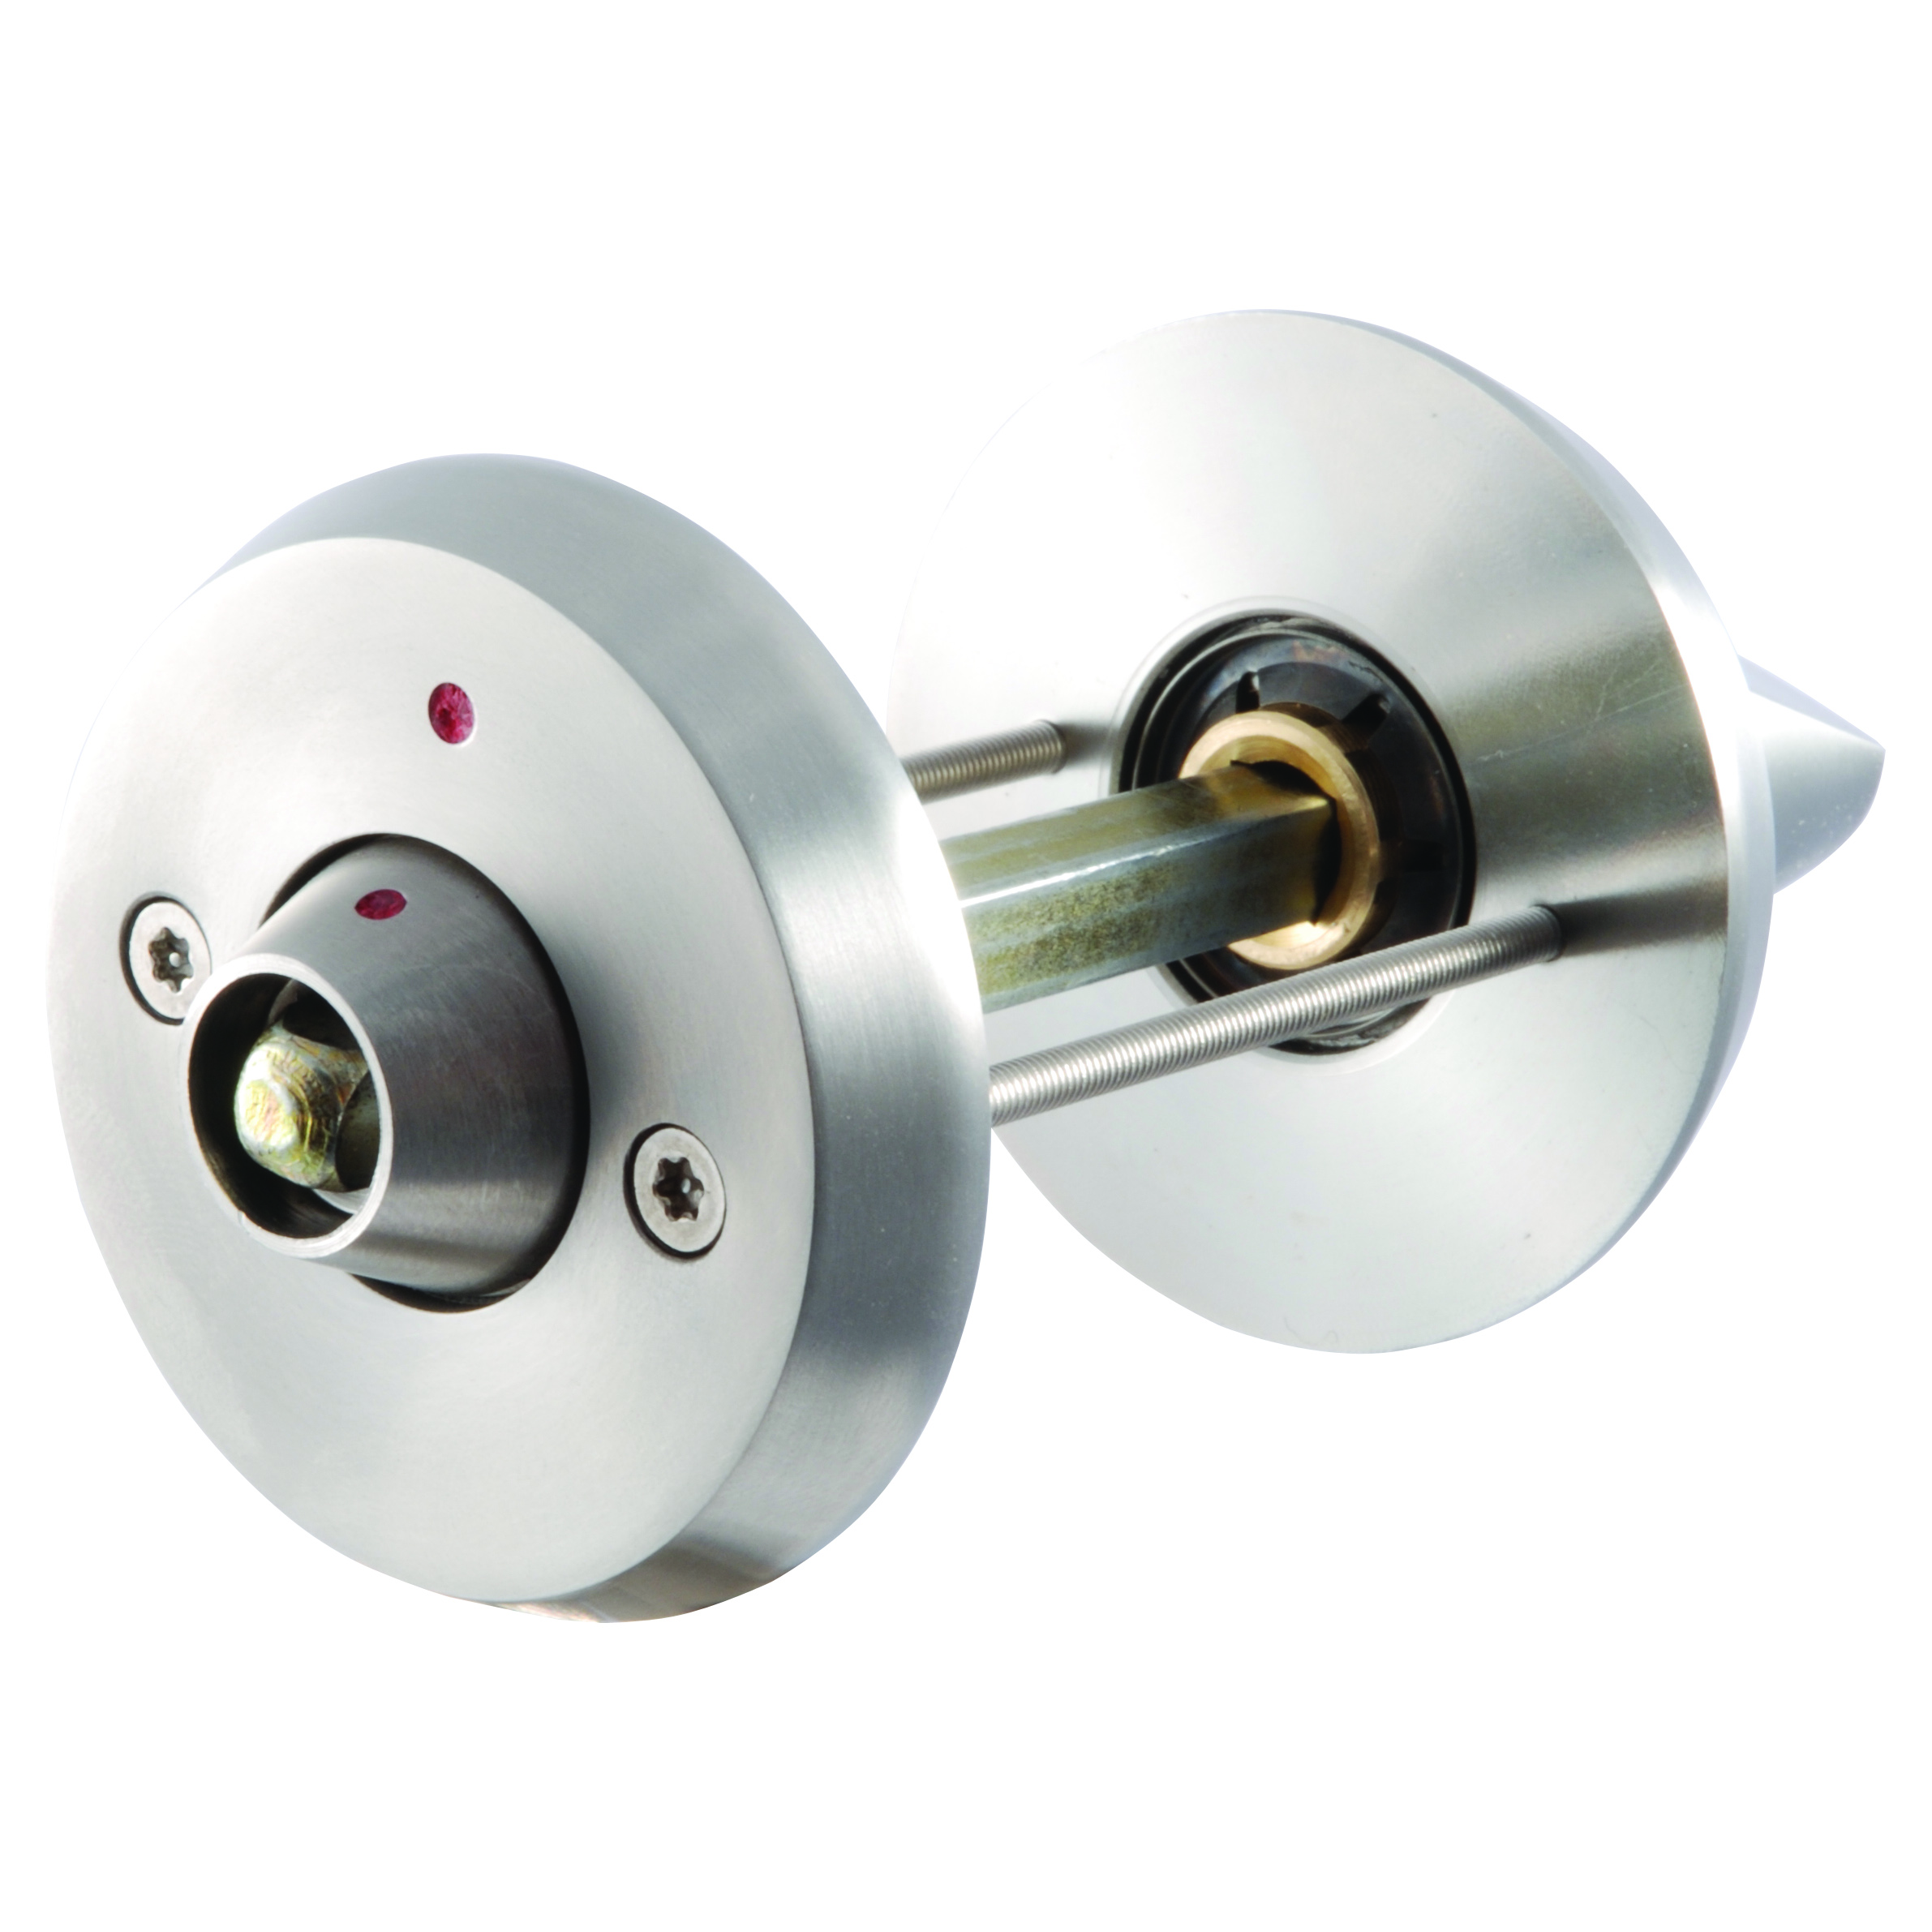

FULL PRODUCT DESCRIPTION anti ligature anti barricading bathroom turn and indicator with coach key release [key provided]

MATERIAL Aisi 304 stainless Steel

DESIGN SPECIFICATION designed for use in facilities where users of the building might self harm either by attaching ligatures to door fittings or attempt to barricade and self harm by holding the turn thus preventing entry by the staff. The product incorporates a clutch mechanism which when the emergency release key is operated and the client is holding the knob the clutch allows the bolt to be released thus giving entry to the facility without delay.
The knob is designed to prevent the attachment of ligatures but easy to operate.
PARTS LIST 1 knob on rose, 1 coach key indicator, 2 torx pin anti tamper screws, 1 spindle, 1 coach key.1 torx pin screw driver head.
FITTING INSTRUCTIONS after prepping the door by drilling a 12mm hole where the spindle will go through the lock with two holes 5mm in dia at 38mm c/c for the torx pin bolt through fixings. Present the knob side to the facility side of the door put the screws through the holes and fixed spindle through the lock follower present the release indicator first ensuring that the indicator dots line up when the door is locked
Tighten the screws with the special bit provided do not use power drivers to fit this product as it will damage the screw heads. Do not adjust the grub screws visible on the sides of the knob these are factory preset On satisfactory installation of this product please hand the screw driver bit and coach key to the facilities manager.
TROUBLE SHOOTING if the clutch does not operate satisfactorily check the following that the lock is straight in both vertical and horizontal planes, the bolt is not fouling on the receiving plate, the door is not warped. Remove the product from the door and check the operation of the set by holding the knob and operating the key if this operates satisfactorily it is likely that the problem is one of the possibilities already detailed. Please phone Dortrend International ltd 01299 827837
CARE AND MAINTAINENCE this product does not require any mechanical maintenance periodically check the screws for tightness and wipe with a damp cloth
TOUCHCLEAN ANTIBACTERIAL COATING all Dortrend products can be supplied with our antibacterial coating which kills 99.9% of MRSA E.coli and other bacteria.

Dortrend International ltd retains the right to change design features of its products without notice if the product featured varies from the above please contact us for an updated product information sheet. Thank you for purchasing our product

