

DORTREND INTERNATIONAL LTD- PRODUCT INFORMATION SHEET

PRODUCT REF.NO ANTWH300BB
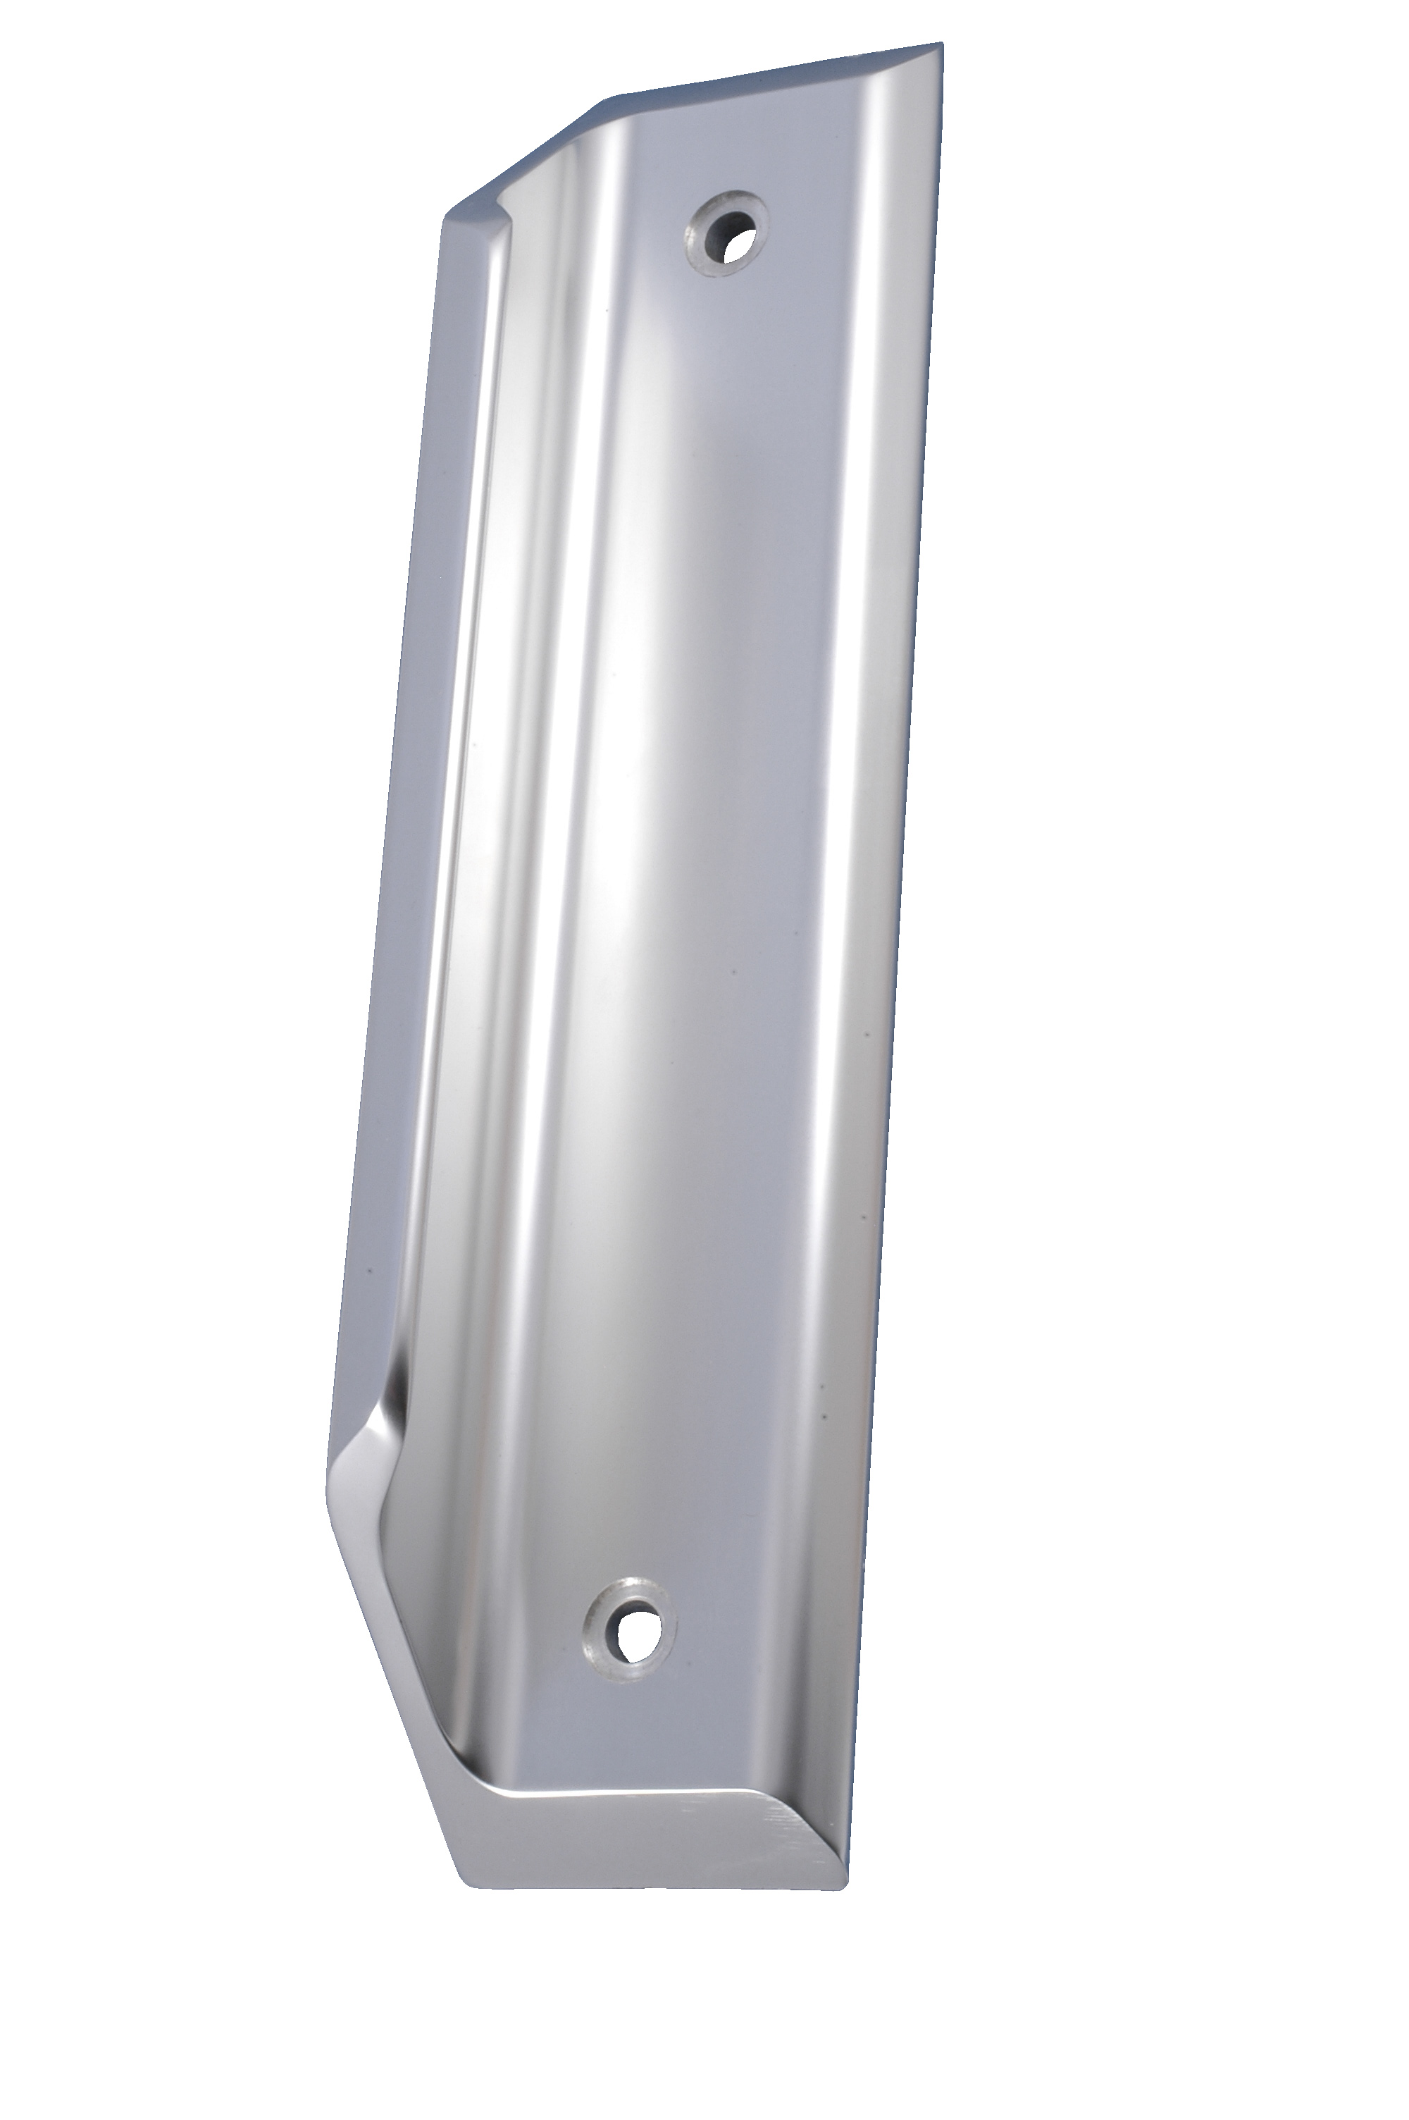
FULL PRODUCT DESCRIPTION anti ligature pull handle bolted back to back

MATERIAL extruded aluminium [also available in stainless steel] anodised

DESIGN SPECIFICATION for use in premises where distressed or vulnerable patients might attempt to self harm by attaching ligatures to door hardware the unique design prevents ligatures being attached and used upwards or downwards. Available in a extensive range of sizes up to 2100mm long.

PARTS LIST pair of anti ligature pull handles pair of anti tamper bolts tool

FITTING INSTRUCTIONS drill two holes 6.5mm dia x 230mm c/c present the handles to the door and bolt them together using the tool provided

TROUBLE SHOOTING handles are not straight on the door – check holes are in line cannot fix to handle on opposite side of the door –hole drilled at an angle through the door. for product support telephone 01299 827837

CARE AND MAINTENCE periodically check tightness of bolts with the tool provided clean handles with warm soapy water DO NOT USE ABRASIVE POLISHES AS THIS WILL SCRATCH THE FINE FINISH WHICH IS SILVER ANODISED.
TOUCHCLEAN ANTIBACTERIAL COATING all Dortrend products can be supplied with our anti bacterial coating which kills 99.9% of MRSA E.Coli and other bacteria.

