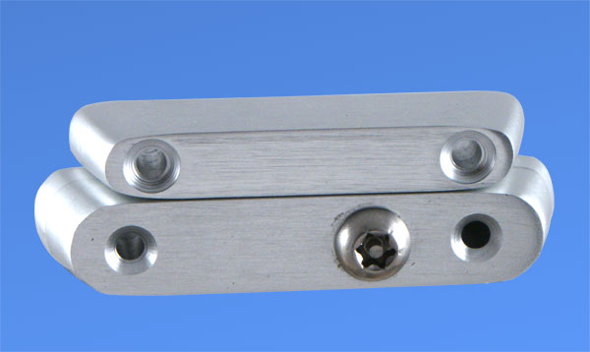 PRODUCT INFORMATION SHEET ANTWCSPAS

PRODUCT CONCEPT designed to be ligature resistant to replace cock spur type window handles and as a solution to retro fitting a fastener onto an existing window saving the expense of replacing windows that have many years service left in them or are in conservation areas.

PRODUCT FEATURES a cockspur contained within a purpose made box section operated by a tamperproof Torx pin head operated by a cranked torx pin key [supplied] note sizes will vary as this product is manufactured to order to suit the window size.Body manufactured from aluminium cocks spur from stainless steel.

CARE and MAINTAINANCE checks the operation of the cockspur regularly if stiff in operation apply a small amount of 3 in 1 oil to the moving parts. Wipe as necessary with a damp cloth do not use abrasive polishes as this will damage the hand polished and anodised finish. If removing the fixing screws do not use power drivers as this will damage the torx pin screws.

